Holmes Chapel Community Pre-school

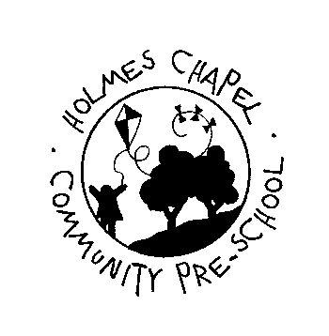

**Holmes Chapel Primary School, Middlewich Road, Holmes Chapel, Cheshire CW4 7EB**

**Registered Charity Number 1017112**

**Member of the Pre-school Learning Alliance**

# Social Media Policy

This social media policy applies to parents, members of staff, students, committee members and volunteers at Holmes Chapel Community Pre-School.

This policy includes (but is not limited to) the following technologies:

* • Social networking sites (e.g. Facebook, Bebo, MySpace)
* • Blogs
* • Discussion forums
* • Collaborative online spaces
* • Media Sharing services (i.e. You Tube)
* • Micro-blogging (i.e. Twitter)

*As part of our duty to safeguard children it is essential to maintain the privacy and security of all our families.*

*We therefore require that:*

No photographs taken within the Pre-School setting or at Pre-School special events and outings with the children, are to be posted for public viewing. (This excludes those photographs taken by staff for the children’s Learning Journey, which are sometimes used for display in the setting, for use on the Pre-School website and in other advertising material if parental permission is given).

No public discussions are to be held or comments made on social media sites regarding the Pre-school children, staff or committee business (except appropriate use for marketing fund raising events) or that could be construed to have any impact on the Pre-School’s reputation or that would offend any member of staff or parent using the Pre-School.

Any member of staff, student or volunteer found to be posting remarks or comments that breach confidentiality or that are deemed to be of a detrimental nature to the Pre-School or other employees, or posting/publishing photographs of the setting, children or staff may face disciplinary action in line with the Pre-School disciplinary procedures (students will be asked to leave immediately).

Any comment deemed to be inappropriate is to be reported to the Chair and Manager and any action taken will be at their discretion.

*General guidelines for using social media:*

Remember that no information sent over the web is totally secure and as such if you do not wish the information to be made public refrain from sending it through social media.

Maintain professionalism, honesty and respect.

Apply a “good judgement” test for every social media post you make.

*Note*

Holmes Chapel Community Pre-School Committee will use social media to advertise fund raising events throughout the year and to share weekly learning objectives and special events.

Version dated: January 2015

Review date: April 2015